Exceptions:
Error and exception:
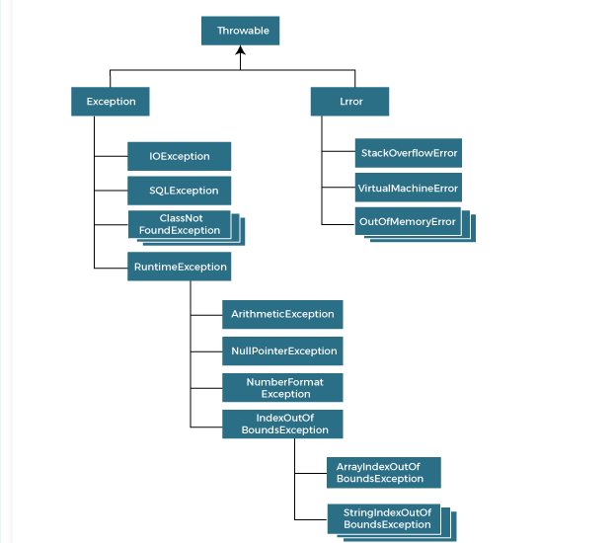
Exceptions can be handled but we cannot handle the error.
Throwable is a class not an interface.
Throwable class is extended by Exception and error.
Exception :
Checked Exception: Handle in the compile time and these are recoverable.
IO Exception, SQL Exception.
Unchecked Exception:
Runtime Exception:
ArraysIndexOutOfBound Exception
StringIndexOutOfBound Exception.
Arithmatic Exception.
